APDTest   
User Guide

(Command line test Interface for   
APDCAM and APDCAM-10G)

Version: 1.1

Last modified: 21.07.2016.

1. **Introduction**

This document describes details about how to use APDTest software. This software is capable to run under Windows and Linux as well.(Only Linux support for APDCAM-10G for now). APDTest was tested under the following operating systems:

* Windows 7, 64bit
* CentOS 6, 64bit
* Ubuntu 16.04 LTS, 64bit

1. **Requirements**
   * APDCAM or APDCAM-10G connected to a computer which is used to control one of the cameas.
   * Network settings necessary to communicate with APDCAM
   * Visual C++2013 Redistributables installed to be able to run the software (for windows only)
2. **Using the software**

The software can be controlled by a script file which can contain command from the following table.

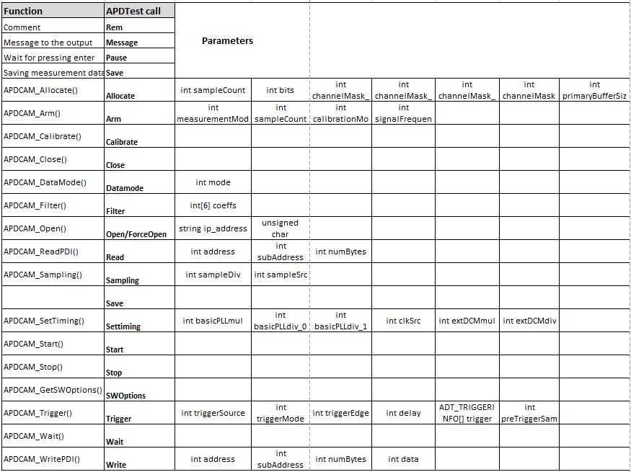

APDTest commands

The following example contains commands with parameters for a usual measurement with APDCAM.

Message *************** APD Camera demo *****************

Message This script demonstrates the simple, untriggered operation of ADC board.

Open 10.123.13.101

Rem SetTiming: p1=adc mult, p2=adc div, p3=stream mult, p4=stream div

SetTiming 20 40 30 10

Rem Sampling: p1=sampleDiv, p2=sampleSrc 0:internal, 1:external

Sampling 20 1

Rem Allocate: p1=sample num, p2=bit num, p3=channel_1 mask, p4=channel_2 mask, p5=channel_3 mask, p6=channel_4 mask,

Allocate 1000000 14 255 255 255 255

Rem Arm: p1=measurement mode (0:one shot 1:cyclic) p2=sample num, p3=calibration mode (0:calibrated 1:non-calibrated)

Arm 0 1000000 0

Start

Wait 5000

Save

Pause

Close

The software has only one parameter which is the script file name (and path if it is not in the same directory as the software). If APDTest is called without any parameter, the default config file name will be „APDMain.txt” and the software will tries to open it in the same directory as it is running from. On the following screenshot you cab see the tipical output of the software.

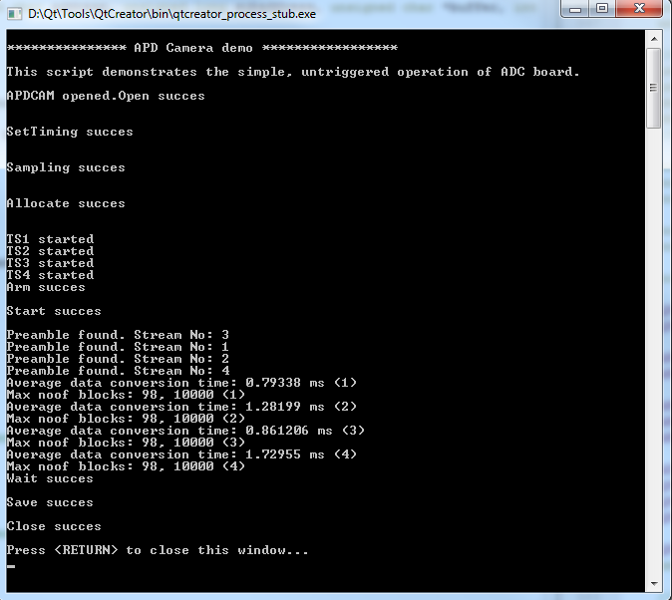

APDTest output

1. **Support**

If you have any further questions of want to report a bug please contact us by email:

[support@fusioninstruments.com](mailto:support@fusioninstruments.com?subject=APDTest)